**Electric Vehicle Policy of Assam, 2021**

**Relevant for all Mahindra EV**

**4th September 2021**

**Background**

The Assam Government envisions that EVs will make for 25 per cent of all new vehicle registrations by 2026. Assam also plans to convert 100 per cent of its public transport bus fleet into electric buses (battery EVs) by 2030, which is when all government vehicles will also be converted into EVs.

**Salient Features**

* As part of the ‘Electric Vehicle Policy of Assam, 2021’, the government will create infrastructure for electric vehicles, including a network of charging points, nurture a skilled workforce for the sector, and make Assam the preferred destination for electric vehicle and component manufacturing by investing in cutting edge technologies.
* EV charging companies will be eligible for 25 per cent capital subsidy on equipment subject to a maximum limit of Rs 10 lakh per station
* The state government will exempt 100 per cent electricity duty of EV charging stations and offer state-specific incentives for manufacturing EVs or EV components, in addition to the 30 per cent capital investment subsidy available under North East Industrial Development Scheme (NEIDS) 2017 or any subsequent policy from the Centre, according to the draft.
* The policy mentions incentives for ownership, manufacturing and subsidies.
* There are exemptions and reimbursements for registration charges and road tax for all EVs till 2026.
* There is also a retro-fitment incentive of 15 per cent up to Rs 15,000 for auto rickshaws.

**Policy targets**

The state government of Assam will support the deployment of the first 200,000 EVs either under commercial use or individual use over the next five years. The segment wise targets are as follows:

* Two-wheeler (2W) EVs – 100,000 units
* Three-wheeler (3W) EVs – 75,000 units
* Four-wheeler (4W) EVs – 25,000 units

**Demand Incentives**

The Assam government will provide the following demand incentives in addition to the incentives provided by federal government schemes. These state government incentives will be based on battery capacity. The maximum amount of subsidy must not exceed 40 percent of ex-factory price of the EV.

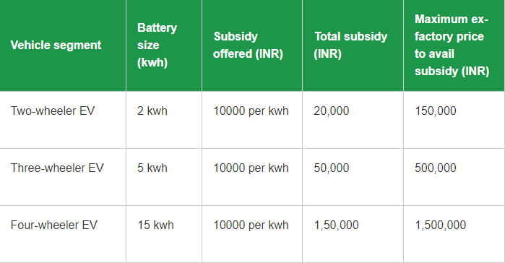

The Assam EV policy provides a waiver on road tax and registration charges for EVs for next five years. Additionally, the policy also provides a 100 percent waiver on parking charges for EVs till 2026.

The policy also proposes retro fitment incentive at 15 percent up to INR 15,000 for three-seater auto rickshaws.

**Incentives for manufacturing of EVs and EV components**

In addition to the 30 percent capital investment subsidy available under the North East Industrial Development Scheme (NEIDS), the Assam EV policy prescribes following incentives for units manufacturing EV or their components:

* 20 percent of cost of plant and machinery up to INR 1.5 million for micro, small, and medium (MSME) units
* 10 percent of cost of plant and machinery up to INR 100 million for large production units

Recycling policy for batteries and EV

Under the Assam EV policy, the EV owners can exchange vehicle batteries that have reached their end of life at any charging point or swapping station in return for a compensation amount. The policy disallows disposal of EV batteries in any other manner, including scrappage.

Furthermore, a nodal agency will be appointed to act as an aggregator to purchase EV batteries from the charging points and battery swapping stations. These batteries will be further reused as power banks to store renewable energy.